RESOLUTION NO.__________

RE: CERTIFICATE OF APPROPRIATENESS UNDER THE
PROVISIONS OF THE ACT OF THE PENNSYLVANIA
LEGISLATURE 1961, JUNE 13, P.L. 282 (53
SECTION 8004) AND BETHLEHEM ORDINANCE NO.
3952 AS AMENDED.

WHEREAS, it is proposed to install three new antennaes at 437 Main St.

NOW, THEREFORE, BE IT RESOLVED by the Council of the City of Bethlehem that a Certificate of Appropriateness is hereby granted for the proposal.

Sponsored by: (s)

(s)

ADOPTED BY COUNCIL THIS DAY OF

(s)
President of Council

ATTEST:

(s)
City Clerk

HISTORICAL & ARCHITECTURAL REVIEW BOARD

The applicant proposes to replace one antenna and install two new antennae matching the existing, mounted on the roof & penthouse
wall at 437 Main St.
APPLICATION #1:

Christmas City Hotel
437 Main St.
Bethlehem, PA 18018

OWNER:

__________________________________________________________________

The Board upon motion by Nancy Shelly and seconded by Marsha Fritz adopted the proposal that City Council issue a Certificate of Appropriateness for the following:

- Install three new antennae in locations previously approved.

2. Tops to be matching and the wall mounted antenna to be painted to match the
wall.

3. The motion was unanimously approved.

__________________________________________________________________________

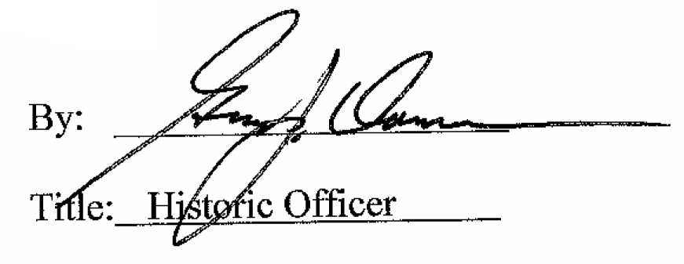

Date of Meeting: November 4, 2015

